DBT Assignment 10
- Write a procedure that computes the perimeter and the area of a rectangle. Define your own values for the length and width. (Assuming that L and W are the length and width of the rectangle, Perimeter = 2*(L+W) and Area = L*W.

DELIMITER $$
CREATE PROCEDURE area_perimeter(length INT, breadth INT)
BEGIN
SELECT length AS L, breadth AS B, length*breadth AS AREA, 2*(length+breadth) AS PERIMETER;
END
$$
DELIMITER ;
CALL area_perimeter(4,5); 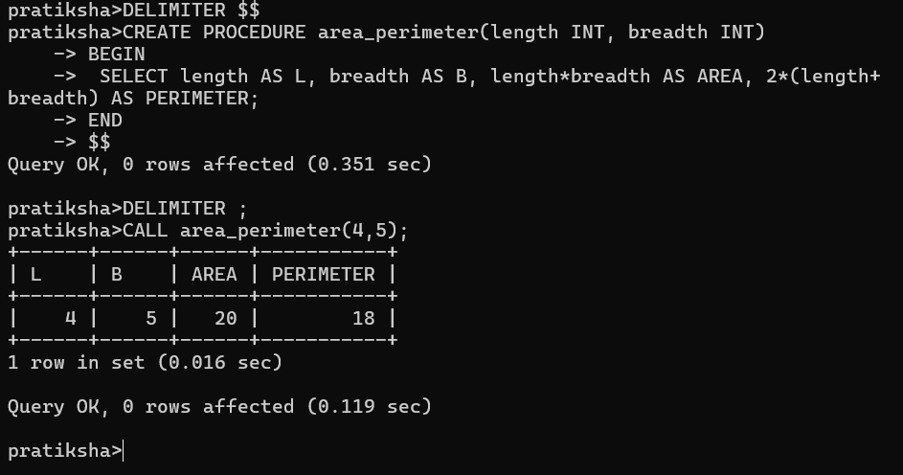

- Write a procedure that declares an integer variable called num, assigns a value to it, computes and inserts into the temp table the value of the variable itself, its square, and its cube.

DELIMITER $$
CREATE PROCEDURE squ_cube(num INT)
BEGIN
DECLARE val INT;
SET val = num;
INSERT INTO temp VALUES(val, val*val, val*val*val);
END
$$
DELIMITER ;
CALL squ_cube(5); 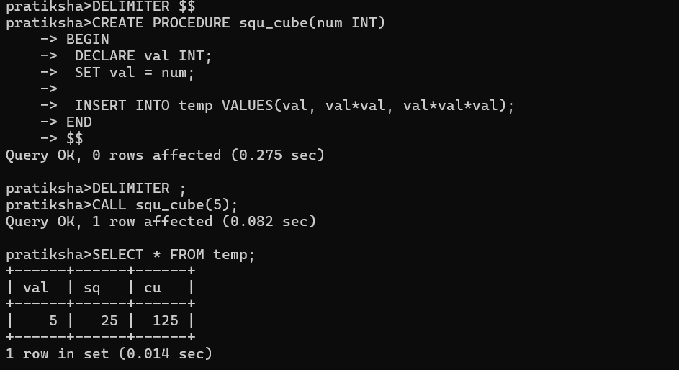

- Create a procedure to Convert a temperature in Fahrenheit (F) to its equivalent in Celsius (C) and vice versa. The required formulae are C= (F-32) *5/9 F= 9/5*C + 32

DELIMITER $$
CREATE PROCEDURE fah_cel(num INT, temp CHAR(2))
BEGIN
DECLARE res DOUBLE;
IF temp = 'c' THEN
SET res = (9/5)*num+32;
SELECT num AS Celsius, res AS Fahrenheit;
ELSE
SET res = (num-32)*5/9;
SELECT num AS Fahrenheit, res AS Celsius;
END IF;
END
$$
DELIMITER ;
CALL fah_cel(113, 'f'); 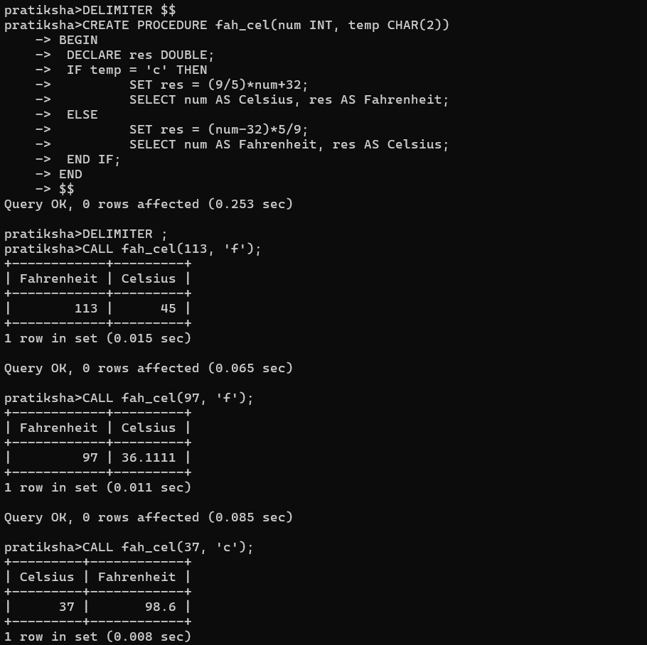

- Create a procedure to Convert a number of inches into yards, feet, and inches. For example, 124 inches equals 3 yards, 1 foot, and 4 inches.

DELIMITER $$
CREATE PROCEDURE inch_con(inch INT)
BEGIN
DECLARE res1 INT;
DECLARE res2 INT;
DECLARE res3 INT;
SET res1 = inch / 36;
SET res2 = (inch % 36) / 12;
SET res3 = (inch % 36) % 12;
SELECT inch AS Input, res1 AS Yards, res2 AS Feet, res3 AS inches;
END
$$
DELIMITER ;
CALL inch_con(124); 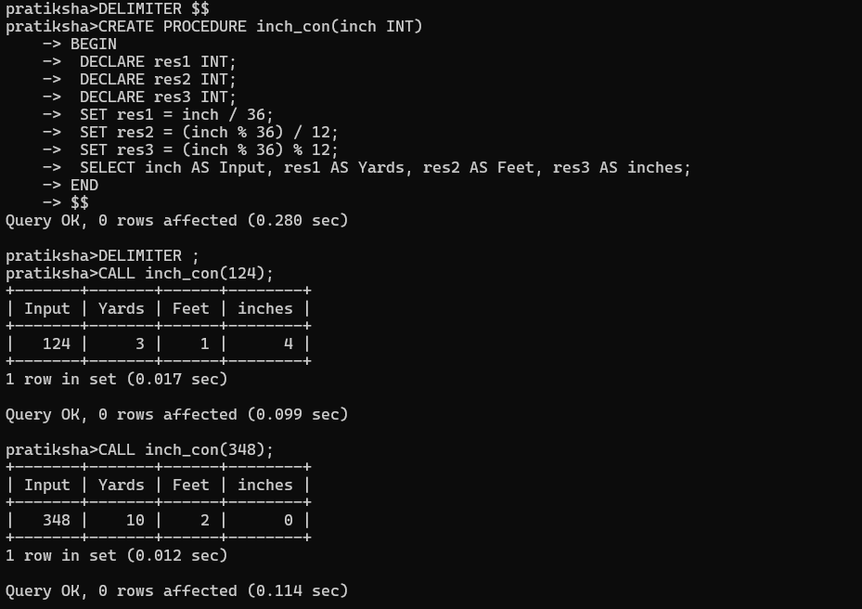

- Create a procedure to read two real numbers and tell whether the product of the two numbers is equal to or greater than 100.

DELIMITER $$
CREATE PROCEDURE compair(val1 INT, val2 INT)
BEGIN
DECLARE res INT;
SET res = val1 * val2;
IF res < 100 THEN
SELECT CONCAT('Multiplication of ', val1, ', ', val2, ' is less than 100') AS Result;
ELSEIF res = 100 THEN
SELECT CONCAT('Multiplication of ', val1, ', ', val2, ' is less equal to 100') AS Result;
ELSE
SELECT CONCAT('Multiplication of ', val1, ', ', val2, ' is greater than 100') AS Result;
END IF;
END
$$
DELIMITER ;
CALL compair(4, 5);

